President’s Office
REGIONAL ADMINISTRATION AND LOCAL GOVERNMENT
ARUSHA DISTRICT COUNCIL
FORM FOUR PRE-MOCK EXAMINATION - MARCH 2020
013 GEOGRAPHY
Time:3Hours Monday,30th March 2020 a.m
INSTRUCTIONS:
- This paper consists of section A, B and C.
- Answer all questions in section A and B and any two questions form section C.
- Map extract of SONGWE RIVER (sheet 244/3) is provided.
- Programmable calculators, cellular phones and un authorized materials are not allowed
- Credit will be given for the use of relevant sketch maps and diagram
- Write your examination number in every page of your answer sheet

SECTION A (15 Marks)
Answer all questions in this section

- For each of the items (i) – (x) choose the correct answer from among the given alternatives and write its letter in the boxes provided.

  - Which of the following features does not occur from depositional factors;

A. Ox-blow lake
B. Meanders
- Delta
- U-shaped valley
- Flood plain ( )

  - Mechanical weathering of rock is favorable where there is;
- Very high temperature
- High day temperature followed by high night temperature
- Very low temperature throughout the year
- Rapid change of temperature
- Little vegetation ( )

  - Assume that your at the top of mountain, then you see a river flowing which looks like a tree with its branches. What is the general term of that river drainage pattern?

- Trellised
- Dendritic
- Radial
- Centripetal
- Annual ( )

(iv) The main concentric zones of the earth are:
- Zone of discontinuity low pressure zone and aquatic zone
- Troposphere, stratosphere and mesosphere
- Atmosphere, hydrosphere and thermosphere
- Lithosphere, mesosphere and atmosphere
- Mantle, Core and Crust ( )
- If the temperature at 500m where the tourists start climbing mount Kilimanjaro is 20⁰ C, what will be the temperature when they reach 2000m above sea level?

- 10⁰C
- 5⁰C
- 11⁰C
- 12⁰C
- 15⁰C ( )

- Meander and ox-bow lakes are characteristic features of rivers in:

- The young stage
- The long profile stage
- The old stage
- The middle stage.
- Upper course ( )

- Mr. Mtakuja is a geography teacher at Kibaha secondary school, he was teaching about external forces affecting the earth. Within the content he chosen a certain student to define the term denudation.Denudation in a weathering process involves:
- Erosion, volcanicity, vulcanicity
- Gravity, mass wasting deposition
- Rockfall, mudflow, soil creep ( )
- Erosion, transportation, deposition
- Erosion, mass wasting and weathering
- The period when the length of day and night are believed to be equal all over the world
- 23rd September and 22nd December
- 21st June and 23rd September
- 21st march and 22nd June
- 23rd September and 21st march
- 23rd September and 22nd January ( )

- The temperature and pressure decreases with an increasing altitude at the rate of 0.6⁰C per 100m ascend. This occurs in;

- Troposphere
- Hydrosphere
- Mesosphere
- Stratosphere
- Thermosphere ( )

- After learning different types of soil texture, student were asked to identify the best types of soil which can be mixed with cement for building a house. What type of soil will be picked?

- Sandy
- Silt
- Loam
- Clay
- Alkaline soil ( )

- Match the responses in List B with the phrases in List A by writing the letter of the correct responses beside the item number.
LIST A | LIST B
- Lake Chad  - Barometer  - Asthenosphere  - Seismometer  - Mud flow | - Inland Drainage Lake.  - The crust  - Slow mass movement.  - Basin Lake.  - An instrument used to measure pressure.  - Rapid mass movement.  - The mantle  - An instrument used to measure an Earthquake.  - An instrument used to measure humidity.  - A scale used to measure the magnitude of Earthquake.

SECTION B (55 Marks)
Answer all questions in this section

- Carefully study the map extract of SONGWE RIVER( Sheet 244/3) provided then answer the questions that follow:
- Calculate area covered by forest in km²
- Name ways that have been used to express a map scale
- With evidences from the map, outline three social services provided in the area
- Suggest the type of climate of the mapped area. Give at least one reason to support your answer (two climates)
- Name the features found in the following grid references
  - 065114
  - 115185
  - 015143

- (a) Sara is a good surveyor; she intends to determine the actual height of the ground of a certain area. What type of survey techniques would you advise her to apply?
(b) Analyze other four significance of the type of survey techniques applied above.
(c) Explain five essential equipments used in the technique you have mentioned above.

5. Study the cash crop production in East Africa in tones.

CROPS | COFFEE | SISAL | TOBACCO
PERIOD
1990 | 100 | 600 | 200
1991 | 800 | 300 | 800
1992 | 250 | 850 | 700

    - Draw a group Bar graph to show the production of cash crops in Tanzania from 1990-1992(000) tones.
    - Comment on the trend of production (three comments)

- (a) Suppose you want to prepare questionnaires about a certain research topic. What procedures
will you consider when preparing questionnaires?
(b) Mention four advantages and three disadvantages of questionnaires as a tool of data
Collection

7. Carefully study the photograph below, and then answer the questions that follows

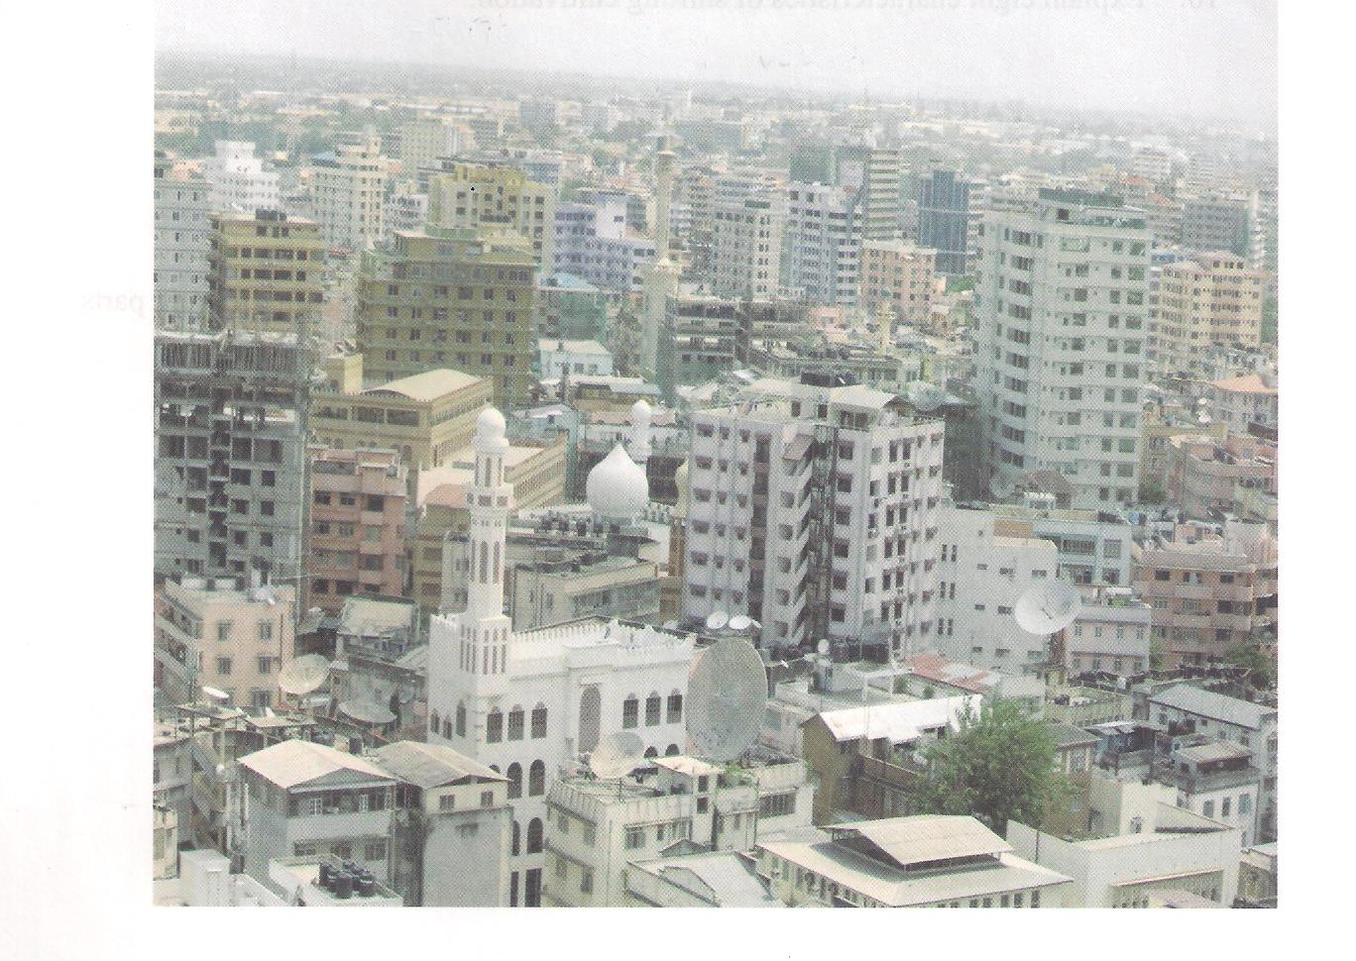
- With two reasons, identify the type of the photograph.
- Identify the type of the settlement type seen on the photograph.
- Name two economic importance of the area shown on the photograph.
- Explain two environment problems that are likely to occur in the area.
- Suggest at least three places at which the photograph might be taken

SECTION C (30 Marks)
Answer only two questions only in this section

8. Agriculture is backbone of many countries in Africa and world at large. In Tanzania
agriculture sector only employed more than 70% of population, but still it not doing well
as compare to the rest of world. Give out seven (7) ways to solve the situation

9. Tourism is one of sector of economy which its rate of contribution to national income
increases each year. Using Tanzania as case study elaborate seven (7) factors accelerate
tourism in Tanzania

10. “Discovering of minerals in many part of Tanzania contributes social and economic
development. Explain seven (7) negative effect of mining industry to the environment.

